**A Project Report**

**ON**

**CAMPUS MANAGEMENT SYSTEM**

**SUBMITED BY**

**Name: sushrita barik**

**UNDER THE GUIDANCE OF:**

**Mr. ASHWINI ROUT**

**(Project Guide)**

**BETA CENTAURI PRIVATE LIMITED**

**BHUBENESWAR-751024**

TABLE OF CONTENTS

1.Design Document........................................7

2.Program specification........................................12

3.Requirement study..............................................26

3.1. Introduction.............................................27

3.2. Objective..................................................28

3.3. Scope.......................................................29

3.4. Benefits....................................................30

3.5. Flowchart....................................................31

3.6. ERD................................................................32

3.7 DFD...............................................................33

4. Functional study....................................................34

4.1. Functional Requirement............................35

DESIGN DOCUMENT

TABLE NAME- STUDENT_INF

PK- User-ID

DESCRIPTION- Student information

|  |  |  |  |  |
| --- | --- | --- | --- | --- |
| Field name | Datatype | Null | Key | Description |
| Sl No | int | N |  | Serial no |
| Student ID | Varchar(10) | N | PK | Student id |
| Student Name | Varchar(40) | N |  | Name of the student |
| DOB | DateTime | N |  | Date of birth |
| DOA | DateTime | N |  | Date of admission |
| Mobile | Varchar(10) | N |  | Mobile number |
| Address | Varchar(40) | N |  | Address of student |
| A.of.class | Varchar(11) | N |  | Absent of student |
| Grade | Varchar(6) | N |  | Grade |
| P.of.class | Varchar(11) | N |  | Present of student in class |

TABLE NAME- Company_INF

PK- Company-ID

DESCRIPTION- Company information

|  |  |  |  |  |
| --- | --- | --- | --- | --- |
| Field Name | DataType | Null | key | Description |
| Sl No | INT | N |  | Serial No |
| Company Name | VARCHAR(40) | N |  | Name of the company |
| Company Id | VARCHAR(10) | N | pk | Company id |
| Company Establish | VARCHAR(4) | N |  | Starting date of company |
| Mobile | VARCHAR(10) | N |  | Mobile number of company |
| Address | VARCHAR(40) | N |  | Address of company |
| Email Id | VARCHAR(20) | N |  | Mail id of company |

TABLE NAME- College_INF

PK- College-ID

DESCRIPTION-College information

|  |  |  |  |  |
| --- | --- | --- | --- | --- |
| Field Name | DataType | Null | Key | Description |
| Sl No | INT | N |  | Serial No |
| College ID | VARCHAR(10) | N | PK | College id |
| Student Number | VARCHAR(80) | N |  | Number of student |
| Selected Student in Campus | VARCHAR(30) | N |  | Number of selected students in campus |
| College Name | VARCHAR(40) | N |  | Name of college |
| College Establish | VARCHAR(4) | N |  | Starting date of college |
| Faculity Number | VARCHAR(20) | N |  | Number of faculity |
| Mobile | VARCHAR(10) | N |  | Mobile number of college |
| Email | VARCHAR(30) | N |  | Email id of college |
| Address | VARCHAR(50) | N |  | Address of college |

PARENTS NAME- Parents_INF

PK- Parents-ID

DESCRIPTION-Parents information

|  |  |  |  |  |
| --- | --- | --- | --- | --- |
| Field name | DataType | Null | Key | Description |
| Sl No | INT | N |  | Serial Number |
| Parent ID | VARCHAR(10) | N | PK | Parent id |
| Parent Name | VARCHAR(40) | N |  | Name of the parent |
| Mobile | VARCHAR(10) | N |  | Mobile number of the parent |
| Address | VARCHAR(40) | N |  | Address of the parent |
| Email | VARCHAR(30) | N |  | Mail id of the parent |

**PROGRAM SPECIFICATION**

|  |  |
| --- | --- |
| USER ID | PASSWORD |

**Admin Login**

|  |  |  |  |  |  |  |
| --- | --- | --- | --- | --- | --- | --- |
| TOTAL STUDENT | PLACESTUDENT IN MCA | NAME OF STUDENT WHO SELECTED IN MCA BRANCH | COMPANY NAME | COMPANY SALARY IN ANNUAL | COMPANY CRITERIA | HOW MANY COMPANY CAME IN 2019 |
| 120 | 20 | SUSMI BEHERA  SAROT BEHERA  SYAM DASH  SANJANAMISRA  RUPALI DAS  RUBI ROUT  PIUSH SAHOO  SASI DAS  MONA DAS  SUSMITA NAYAK  LIZA PATI  RANJITA DAS  RENU DAS  Rakesh sahoo  Santana sahoo  Rupesh das  Rakha sahoo  Omm das  Anuska das | IBM  TCS  INFOSIS  WIPRO  ABACUS  CAPEGEMINI  TCS  GOOGLE  SAMSUNG  KUNGAN SOFT  INFOSIS  WIPRO  BETA CENTURY  BETA CENTURY  BETA CENTURY  CSM  CSM  DOLPHIN  ABACUS | 3 LAKH  4LAKH  6LAKH  5 LAKH  2 LAKH  3 LAKH  4 LAKH  5 LAKH  4 LAKH  2.5 LAKH  6 LAKH  5 LAKH  2 LAKH  2 LAKH  2 LAKH  2.5 LAKH  2.5 LAKH  2 LAKH  2 LAKH | 55%CARRIER  60%CARRIER  60%CARRIER  50%CARRIER  50%CARRIER  60% CARRIER  60% CARRIER  65% CARRIER  55%CARRIER  50%CARRIER  50%CARRIER  60%CARRIER  50%CARRIER  50%CARRIER  50%CARRIER  55%CARRIER  55%CARRIER  53%CARRIER  50%CARRIER | IBM  WIPRO  TCS  INFOSIS  SAMSUNG  GOOGLE  CAPAGIMIN  DOLPHIN  BRTA CENTURY  ABACUS  ATMPHOSIS  WIPRO  CSM |
| INPUT:  USER NAME  PASSWORD | | | | | | |
| OUTPUT: 2019 SELECTED STUDENTS IN MCA BRANCH IN THIS COMPANY AND OUR CLG ALSO MANY STUDENTS SELECTED IN OTHER COLLEGE AND MOST MNC COMPANY ALSO CAME IN OUR COLLEGE AND 50% STUDENT ARE SELECTED IN OUR COLLEGE BOTH MCA AND BTECH BRANCH.ITS ALL ABOUT PREVIOUS YEAR CAMPUS DATA | | | | | | |

2019 MCA PASSOUT(PLACED STUDENTS)

|  |  |  |  |  |  |  |
| --- | --- | --- | --- | --- | --- | --- |
| TOTAL STUDENT | PLACESTUDENT IN MCA | NAME OF STUDENT WHO SELECTED IN MCA BRANCH | COMPANY NAME | COMPANY SALARY IN ANNUAL | COMPANY CRITERIA | HOW MANY COMPANY CAME IN 2019 |
| 100 | 25 | SUSMI BEHERA  SAROT SAHOO  RAJA DASH  ANJANAMISRA  RUPA DAS  ROSI ROUT  PINAKI SAHOO  SASMITA DAS  MONALISA DAS  SUSMITA RAY  LIMA PATI  AMBIKA DAS  REKHA DAS  RAJESH SAHOO  ANJALI SAHOO  RUPESH DAS  REKHA SAHOO  OMM DAS  ANUSKA DAS  SHYMA DAS  RAHUL DAS  RAJ ROUT  SONU SAHOO  SUMAN DASH | IBM  TCS  INFOSIS  WIPRO  ABACUS  CAPEGEMINI  TCS  GOOGLE  SAMSUNG  APMSYIS  INFOSIS  WIPRO  BETA CENTURY  BETA CENTURY  BETA CENTURY  CSM  CSM  DOLPHIN  ABACUS  ABACUS  CSM  WIPRO  TCS  INFOSIS | 3 LAKH  4LAKH  6LAKH  7 LAKH  2 LAKH  3 LAKH  4 LAKH  5 LAKH  4 LAKH  2.5 LAKH  6 LAKH  7 LAKH  2 LAKH  2 LAKH  2 LAKH  2.5 LAKH  2.5 LAKH  2 LAKH  2 LAKH  2 LAKH  2.5 LAKH  7 LAKH  4 LAKH  6 LAKH | 55%CARRIER  60%CARRIER  60%CARRIER  50%CARRIER  50%CARRIER  60% CARRIER  60% CARRIER  65% CARRIER  55%CARRIER  50%CARRIER  50%CARRIER  60%CARRIER  50%CARRIER  50%CARRIER  50%CARRIER  55%CARRIER  55%CARRIER  53%CARRIER  50%CARRIER | IBM  WIPRO  TCS  INFOSIS  SAMSUNG  GOOGLE  CAPAGIMIN  DOLPHIN  BRTA CENTURY  ABACUS  ATMPHOSIS  WIPRO  CSM |
| OUTPUT: OUTPUT: 2019 SELECTED STUDENTS IN BTECH BRANCH IN THIS COMPANY AND OUR CLG ALSO MANY STUDENTS SELECTED IN OTHER COLLEGE AND MOST MNC COMPANY ALSO CAME IN OUR COLLEGE AND 60% STUDENT ARE SELECTED IN OUR COLLEGE BOTH MCA AND BTECH BRANCH.ITS ALL ABOUT PREVIOUS YEAR CAMPUS DATA OF BTECH BRANCH) | | | | | | |

2019 BTECH PASSOUT(PLACED STUDENTS)

|  |  |  |  |  |  |  |
| --- | --- | --- | --- | --- | --- | --- |
| TOTAL STUDENT | PLACEDSTUDENT IN MCA | NAME OF STUDENT WHO SELECTED IN MCA BRANCH | COMPANY NAME | COMPANY SALARY IN ANNUAL | COMPANY CRITERIA | HOW MANY COMPANY CAME IN 2020 |
| 120 | 30 | Kasna das  Rahula das  Raj ray  Pritidas  Mama sahoo  Susri barik  Nilima barik  Nagesh das  Priti das  Ragesh sahoo  Raj das  s.k.ray  sraban das  aliva ray  alpha das  alok mohant  mamali sahoo  samir barik  omm barik  chandan das  chintu sahoo  rahula das  ranjan barik  rakesh sahoo  rasmi sahoo  raj rout  sanu rout  chandita ray  romi barik  sasi barik | Tech Mahindra  TechMahindra  Tcs  Tcs  SAP  SAP  Patni solution  Wipro  Accenture  IBM  IBM  Dolphin  Dolphin  Hcl Technology  Infosis  Infosis  Infosis  Wipro  Wipro  Wipro  Csm  Csm  Dell  Dell  Mpasis solution  Tcs  Tcs  Infosis  Infosis  accenture | 2 LAKH  2LAKH  3 LAKH  3 LAKH  4 LAKH  4 LAKH  2.5LAKH  3LAKH  3LAKH  3.5LAKH  3.5LAKH  1.5LAKH  1.5LAKH  2.5LAKH  3LAKH  3LAKH  3LAKH  3LAKH  3LAKH  3LAKH  2.5LAKH  2.5LAKH  3.5LAKH  3.5LAKH  4LAKH  3LAKH  3LAKH  3LAKH  3LAKH  3LAKH | 55%CARRIER  55%CARRIER  60%CARRIER  60%CARRIER  50%CARRIER  50% CARRIER  50% CARRIER  55% CARRIER  60%CARRIER  50%CARRIER  50%CARRIER  50%CARRIER  50%CARRIER  50%CARRIER  60%CARRIER  60%CARRIER  60%CARRIER  53%CARRIER  50%CARRIER  50%CARRIER  50%CARRIER  50%CARRIER  60%CARRIER  60%CARRIER  50%CARRIER  60%CARRIER  60%CARRIER  60%CARRIER  60%CARRIER  60%CARRIER | Tech Mahindra  Tcs  SAP  Patni solution  Wipro  Accenture  IBM  Dolphin  Hcl Technology  Infosis  Wipro  Csm  Dell  Mpasis solution  Tcs  accenture |
| OUTPUT:IN 2020 MOST OF THE REPUTATED COMPANY CAME IN OUR COLLEGE AND OUR COLLEGE MCA AND BTECH BOTH STUDENT BEST PRFORMANCE IN PREVIOUS YAER TO IN THIS YAER.OUR CLG ALSO INCREASE PLACEMENT STUDENT IN PREVIOUS YEAR .ITS ALL ABOUT CAMPUS HISTORY IN MCA BRANCH IN OUR COLLEGE IN 2020 | | | | | | |

[2020 MCA PASSOUT(PLACED STUDENTS)]

|  |  |  |  |  |  |  |
| --- | --- | --- | --- | --- | --- | --- |
| TOTAL STUDENTS | PLACED STUDENT | NAME OF STUDENT | COMPANY NAME | COMPANY SALARY | COMPANY CRITERIA TO APPLY | HOW MANY COMPANY CAME 2020 |
| 150 | 35 | Kasna sahoo  Rahula behera  Raj rout  Pritish das  Mamali sahoo  Susrita barik  Nilima .p. barik  Nageshwari das  Pritish das  Ragesh sahoo  Ramesh das  s.r.ray  srabani das  aliva rani ray  alpha alok das  dinesh mohant  mamuni sahoo  samiranjan barik  ommnara barik  chandan das  chintu sahoo  rahul das  priti barik  rakesh ray  rasmi misra  rajesh misra  sanu rani rout  chandita rani ray  romi lata barik  sasmita barik  Raghab das  Raj ray  Hara samal  Barsa sahoo  Biswanath das | Tech Mahindra  TechMahindra  Tcs  Tcs  SAP  SAP  Patni solution  Wipro  Accenture  IBM  IBM  Dolphin  Dolphin  Hcl Technology  Infosis  Infosis  Infosis  Wipro  Wipro  Wipro  Csm  Csm  Dell  Dell  Mpasis solution  Tcs  Tcs  Infosis  Infosis  accenture  tcs  tcs  wipro  wipro  infosis  infosis | 2 LAKH  2LAKH  3 LAKH  3 LAKH  4 LAKH  4 LAKH  2.5LAKH  3LAKH  3LAKH  3.5LAKH  3.5LAKH  1.5LAKH  1.5LAKH  2.5LAKH  3LAKH  3LAKH  3LAKH  3LAKH  3LAKH  3LAKH  2.5LAKH  2.5LAKH  3.5LAKH  3.5LAKH  4LAKH  3LAKH  3LAKH  3LAKH  3LAKH  3LAKH  3LAKH  3LAKH  3LAKH  3LAKH  3LAKH  3.5LAKH | 55%CARRIER  55%CARRIER  60%CARRIER  60%CARRIER  50%CARRIER  50% CARRIER  50% CARRIER  55% CARRIER  60%CARRIER  50%CARRIER  50%CARRIER  50%CARRIER  50%CARRIER  50%CARRIER  60%CARRIER  60%CARRIER  60%CARRIER  53%CARRIER  50%CARRIER  50%CARRIER  50%CARRIER  50%CARRIER  60%CARRIER  60%CARRIER  50%CARRIER  60%CARRIER  60%CARRIER  60%CARRIER  60%CARRIER  60%CARRIER  60%CARRIER  60%CARRIER  55%CARRIER  55%CARRIER  60%CARRIER  60%CARRIER | Tech Mahindra  Tcs  SAP  Patni solution  Wipro  Accenture  IBM  Dolphin  Hcl Technology  Infosis  Wipro  Csm  Dell  Mpasis solution  Tcs  accenture |
| OUTPUT: IN 2020 MOST OF THE REPUTATED COMPANY CAME IN OUR COLLEGE AND OUR COLLEGE MCA AND BTECH BOTH STUDENT BEST PRFORMANCE IN PREVIOUS YAER TO IN THIS YAER.OUR CLG ALSO INCREASE PLACEMENT STUDENT IN PREVIOUS YEAR .ITS ALL ABOUT CAMPUS HISTORY IN BTECH BRANCH IN OUR COLLEGE IN 2020 | | | | | | |

[2020 BTECH PASSOUT(PLACED STUDENTS)]

|  |  |  |  |  |  |  |  |
| --- | --- | --- | --- | --- | --- | --- | --- |
| ALL ENGINEERING  COLLEGE IN BBSR | NUMBER OF STUDENT | 60% ABOVE STUDENTS IN CARRIER IN MCA BRANCH | 50% ABOVE STUDENTS IN CARRIER IN MCA BRANCH | 60% ABOVE STUDENTS IN CARRIER IN BTECH BRANCH | 50% ABOVE STUDENTS IN CARRIER IN BTECH BRANCH | PREVIOUS YEAR HOW MANY COMPANY CAME | THIS YEAR HOW MANY COMPANY CAME |
| TRIDENT ACADEMY OF TECHNOLOGY  SILICON  SRUSTI  GITA  GIFT  USBM  ITR  C V RAMAN | 300  250  200  150  240  200  300  350 | 50  50  50  40  100  50  100  150 | 100  50  50  50  40  60  100  50 | 50  100  50  50  60  40  50  100 | 100  50  50  10  40  50  50  50 | 30  40  20  10  35  28  32  22 | 40  35  30  30  40  30  35  36 |
| INPUT:  USER ID(PRIVATE)  PASSWORD | | | | | | | |
| INSTRUCTION->   * Username should not blank. * Password should. * Invalid Username or password. * System locked for three wrong password entered. * Password should expire in 60 days * Password has expired ,change the password | | | | | | | |  |
| OUTPUT: HR LOGIN PAGE | | | | | | | |

**HR Login**

**CAMPUS VIEW**

|  |  |  |  |  |  |  |  |  |  |  |
| --- | --- | --- | --- | --- | --- | --- | --- | --- | --- | --- |
| **CLG NAME** | **HOW MANY FACULITY** | **HOW MANY STUDENT** | **NO OF STUDENT SELECTED IN PLACEMENT IN MCA BRANCH** | **NO OF STUDENT SELECTED IN PLACEMENT IN BTECH BRANCH** | **COMPANY NAME** | **NO**  **OF**  **COMPANYpany**  **CAME**  **IN**  **OUR**  **college** |  |  |  |  |
| TRIDENT ACADEMY OF TECHNOLOGY | **50** | **400** | **50** | **50** | **3.-MINDTREE.jpg**  **7.-HITACHI.jpg**  **15.CAPGEMINI-.jpg**  **16.ARKIN-.jpg**  **17.-SM-CUNSULTANCY-.jpg**  **18.-YUSATA-.jpg**  **22.INFOSYS-.jpg**  **21.TCS-.jpg**  **23.ARTECH-.jpg**  **24.MINDFIRE-.jpg**  **25.SMARTPRIX-.jpg**  **28.-S-P-GLOBAL-.jpg**  **29.-KALINGASOFT-.jpg**  **29.-KALINGASOFT-.jpg**  **57.urjanet-.jpg**  **56.cape-electric-.jpg**  **59.convergent-technology-.jpg**  **60.juspay-.jpg**  **62.stl-silicon-tech-lab-.jpg**  **64.bajaj-allianz-.jpg**  **63.dreamgains-.jpg**  **6.-AGILE-GROUP.jpg** | **30** |  |  |  |  |
| **Output:placement data save successfully** | | | | | | |  |  |  |  |

**REQUIREMENT STUDY**

INTRODUCTION

Each of these sub-features can be easily configurable and can be accessed from the user-friendly interface with high visibility and ability to do CRUD(create, update, read and delete operation) on any data present in the campus database.

The most important sub-features is the Standard Management, which can be used to set up a whole course and as a one-board information center for the courses.

The Campus management features starts from Course Management, Class Room Management, Class management, Activity Management, Subject Management, Hostel management, Exam Management, General Management and Exam Management.

We offer educational institutions dynamic and integrated ERP solutions to run smoothly and streamline their educational operations.  it is a suite combining and handling all portals of the institute from one end; it is a one-stop solution for all the users – students, faculties, admin, alumni, etc.

Students

Admissions and program registration  
Course enrollment  
Calendars, messages and notifications  
Course participation and evaluation  
Time-table  
Assignments  
Online Access to Attendance  
Library Reservation details  
Access to Fee Vouchers  
Progress Report  
Electronic Transcripts  
Instant Messaging about events.

### Faculty

Course management  
Attendance management  
Assessment  
Library access  
Rapid attendance taking  
Electronic grade book for assignments  
Progress report  
Direct communication with Parents.  
Minimal Data Entry  
Great time saver with maximum utility

## Parents

Real time student information  
Attendance record  
Report card and transcripts  
Notification if student is absent in school  
Notification when grades are available  
One click Student’s Academic Progres

### Administration

Admissions and program registration  
Calendars, messages and notifications  
Compliance, security and reports  
Course enrollment  
Examination scheduling and management  
Fee statements  
Term set-up, course catalog and timetables  
Comprehensive Student Information  
Student & Faculty Reports  
Overall Student 360 degree Infor

[Learn more](https://aarsol.com/campus-management-system)

OBJECTIVE

The notion of CMS has spread in the German-speaking world in recent years only and links to older concepts, such as academic information systems (IS). Like these systems, CMS aim at a broad support of all university processes. The university can be conceived as service provider that serves cross-functional and interdepartmental processes, recognizes students as customers, and provides the means to help for self-help (Küpper and Sinz [1998](https://link.springer.com/article/10.1007/s12599-010-0105-9#ref-CR8), p. 3 f.). The goals are similar to those of ERP systems, i.e., the company-wide application of modularized systems that use a centralized database and a single user interface to improve the support of an organization’s business processes. The notion of CMS has spread in the German-speaking world in recent years only and links to older concepts, such as academic information systems (IS). Like these systems, CMS aim at a broad support of all university processes. The university can be conceived as service provider that serves cross-functional and interdepartmental processes, recognizes students as customers, and provides the means to help for self-help (Küpper and Sinz [1998](https://link.springer.com/article/10.1007/s12599-010-0105-9#ref-CR8), p. 3 f.). The goals are similar to those of ERP systems, i.e., the company-wide application of modularized systems that use a centralized database and a single user interface to improve the support of an organization’s business processes.

Similar to the heterogeneous definition of ERP systems, different CMS approaches suggest that an agreed-upon understanding of terms is still missing. Nevertheless, three characteristics have emerged for CMS: (1) A CMS follows the principles of integrated application systems, which, for instance, include a single point of data entry, a single database and user interface, the real-time access to information as well as the support of cross-functional processes. (2) Compared to academic or university IS created as individual software, CMS are specifically designed as standard software, which is modularized and customizable. If necessary, individual requirements can be met by additional programming. (3) From a functional point of view, CMS cover all operational (horizontal integration) as well as all business intelligence (vertical integration) functionalities in higher education (Brune et al. [2009](https://link.springer.com/article/10.1007/s12599-010-0105-9#ref-CR3), p. 486). In both literature and practice two views regarding the functionality may be observed:

1.

In a narrower sense, CMS comprise functionalities for managing teaching and learning. Thus, many vendors enhance their ERP portfolio with CMS. These systems focus on supporting the so-called student life cycle. This includes in particular functions for application and enrollment, student records, and managing courses, evaluations, and alumni relationships.

2.

In a broader sense, CMS offer electronic support not only in the areas of teaching and learning management but also in research and resource management (e.g., human resources and accounting) as well as teaching itself (e-learning). Therefore, they aim at “a comprehensive, web-based mapping of the important elements of a university system and its specific functional relationships, and allow a participatory integration of system elements” (Bieletzke and Beise [2009](https://link.springer.com/article/10.1007/s12599-010-0105-9#ref-CR2), p. 4; translated into English).

3.

In fact, a functional perspective yields many interdependencies between the management of teaching and learning and the management of resources. The academic staff, for instance, typically comprises both teaching and research staff. Therefore, efforts have emerged in literature and practice to link academic learning platforms and the software for managing a university’s administrative functions (e.g., Bucksch et al. [2008](https://link.springer.com/article/10.1007/s12599-010-0105-9#ref-CR4)).

## Major Vendors and Functionality

Currently, many German universities are engaged in implementing or enhancing application systems that can be considered as CMS. Some universities act as providers and offer licenses for their self-developed applications to other universities, such as Bamberg University’s module and exam management system FlexNow![Footnote1](https://link.springer.com/article/10.1007/s12599-010-0105-9#Fn1) or CampusOnline[Footnote2](https://link.springer.com/article/10.1007/s12599-010-0105-9#Fn2) developed by the Technical University of Graz. Although individually developed systems still dominate, the diffusion of commercial standard software is widely expected (Bick and Börgmann [2009](https://link.springer.com/article/10.1007/s12599-010-0105-9#ref-CR1)). Almost from the early days of information technology in higher education, the software and consulting company *HIS* *Hochschul-Informations-System GmbH* [Footnote3](https://link.springer.com/article/10.1007/s12599-010-0105-9#Fn3) dominated the German market. But since the mid-1990s, new vendors entered the market at a rapid pace. These include *SAP AG*,[Footnote4](https://link.springer.com/article/10.1007/s12599-010-0105-9#Fn4) the *Datenlotsen Informationssysteme AG* [Footnote5](https://link.springer.com/article/10.1007/s12599-010-0105-9#Fn5) or *CAS Software GmbH*.[Footnote6](https://link.springer.com/article/10.1007/s12599-010-0105-9#Fn6) More recent examples are open source products, such as *Kuali Student* [Footnote7](https://link.springer.com/article/10.1007/s12599-010-0105-9#Fn7), which is jointly developed by several U.S. universities.

To characterize the functionality of CMS various categorizations along the customer processes were suggested. In particular, the model of the so-called “student life cycle” may be linked to the concept of customer orientation. While this has become a well-known strategy for commercial organizations, the sector of higher education is often attributed an exceptional nature due to the non-economic goals of teaching and research (e.g., Meinert [2007](https://link.springer.com/article/10.1007/s12599-010-0105-9#ref-CR9)). CMS, feature customer orientation primarily in supporting the interactions of a

Similar to the heterogeneous definition of ERP systems, different CMS approaches suggest that an agreed-upon understanding of terms is still missing. Nevertheless, three characteristics have emerged for CMS: (1) A CMS follows the principles of integrated application systems, which, for instance, include a single point of data entry, a single database and user interface, the real-time access to information as well as the support of cross-functional processes. (2) Compared to academic or university IS created as individual software, CMS are specifically designed as standard software, which is modularized and customizable. If necessary, individual requirements can be met by additional programming. (3) From a functional point of view, CMS cover all operational (horizontal integration) as well as all business intelligence (vertical integration) functionalities in higher education (Brune et al. [2009](https://link.springer.com/article/10.1007/s12599-010-0105-9#ref-CR3), p. 486). In both literature and practice two views regarding the functionality may be observed:

,

**SCOPE**

The scope of requirement of the user is to

* Access/search information
* Login to the system through the first page of the application
* Change the password after logging into the system
* View/change his/her details
* Can get help through the help option to view different features of the system
* Students can give feedback on college /staff/any other student
* An admin login should be present who can read as well as remove any uploads
* It is more efficient and convient for the colleges
* It reduces the manpower needed to perform the entire administration by reducing the paper works needed
* If all the work is done by the computer there will be no chance of errors
* More over storing and reterving of the information to easy so work can be done speedily and in time
* Online class functionality can be added
* Online exam functionallty added
* Can evolve as online institution

: SCOPE of the project:

* Institute record
* Student record
* Campus management system
* Campus placement
* New Admission
* College Result
* How many student select in placement
* College result
* Previeous year how many student selected in placemect

BENEFITS---------🡪

After the introduction of self-developed proprietary application systems, CMS represent a ‘second wave’ of IS support in higher education. Being integrated standard software, CMS are a prerequisite for an efficient implementation of the Bologna Process at the operational level and for the advancement of higher education at the strategic level. CMS provide integrated functionality along the entire student life cycle and are vital to manage the increasingly complex and networked range of course offerings. They contribute to the professionalization of software development and maintenance, as well as to automation and re-design of business processes. However, the shape of CMS will evolve as will the sector of higher education. Among the possible future developments are:

1. 1.

From the perspective of the entire system of higher education, the increasing possibility of changing among programs of many institutions. Despite their traditional separation, classical universities, universities of applied sciences as well as cooperative education will increasingly exchange services among each other due to the Bologna reform. The same applies to universities outside Germany which in sum makes the inter-university exchange of data regarding modules, examinations, and students through standardized interfaces, such as those included in standard software, more important.

1. 2.

From the perspective of individual institutions, universities will continue to become more service-oriented to foster their competitive position in the academic “marketplace”. The implementation of the service concept is supported by the evolving *Service Science* which, for examples, foresees the adoption of centralized service centers and desks, the definition of comprehensive customer processes which flexibly include the required services. Service-oriented architectures may be considered as important technological enablers for this development.

1. 3.

From the perspective of “classical” university computing centers, service orientation opens the view to new operational and business models. These may, for example, evolve to act as service providers to other – in particular smaller – universities in terms of business process outsourcing and offer the benefits of CMS as “Software as a Service” (e.g., Wannemacher et al. [2008](https://link.springer.com/article/10.1007/s12599-010-0105-9#ref-CR15), pp. 17 ff.). These developments are linked with the already widespread collaborations between universities in the IT sector, such as the joint operation of data centers (e.g., Leibniz-Rechenzentrum Munich, Germany) or application service provisioning.

1. 4.

From the perspective of CMS vendors, comprehensive solutions for all areas of the student life cycle and the university administration are relevant. Ideally, the components of the CMS solutions are not only interoperable within the reference models of each provider, but also between multiple vendor-specific platforms. Such inter-university standard interfaces on a national and even international level, however, require a broad cooperation between vendors and academic organizations. Ultimately, given the budget constraints in many universities, the open source movement will also be important to consider in the CMS area (Panettieri [2008](https://link.springer.com/article/10.1007/s12599-010-0105-9#ref-CR11)).

Similar to the experiences obtained in the ERP area, universities need to carefully assess the costs and the risks of a complex implementation when transforming their organization’s operations. Thus, the introduction of CMS calls for the standardization of a university’s services and business processes as well as data structures. Therefore, the cooperation among faculties and other previously highly autonomous organizational units is critical. Universities with experience in CMS implementation report that the major challenges are not within the technical but the organizational transformation (Janneck et al. [2009](https://link.springer.com/article/10.1007/s12599-010-0105-9#ref-CR7)). Only the successful migration along these political, strategical, organizational, and technological dimensions, ultimately taps all potential benefits of a CMS.

## Notes

:

Flow chart

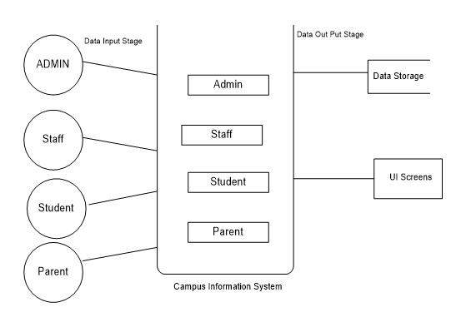

ER DIAGRAM:

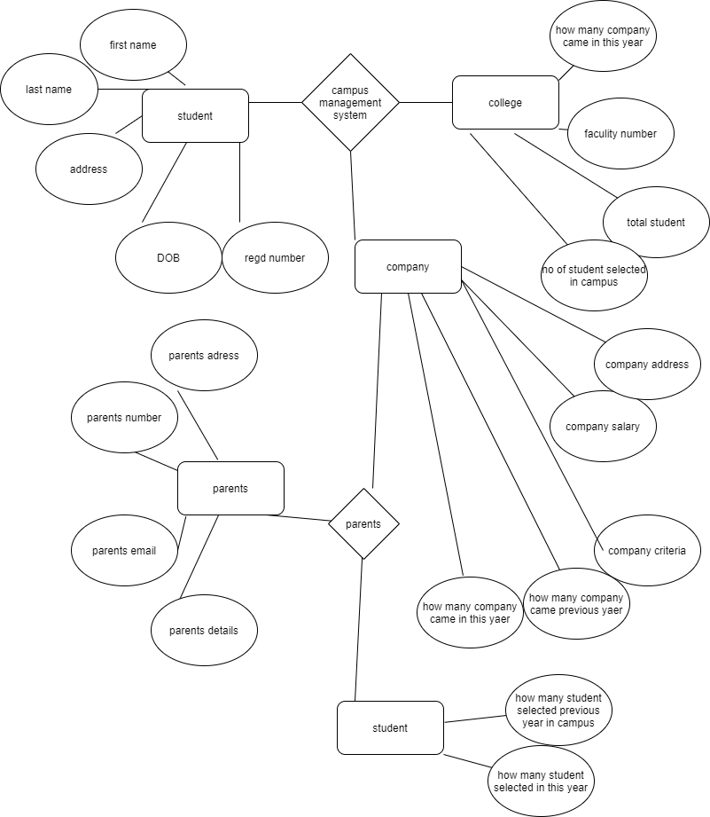

3BentryY%3D1.025%3BentryDx%3D0%3BentryDy%3D0%3BentryPerimeter%3D0%3B%22%20edge%3D%221%22%20source%3D%2235%22%20parent%3D%221%22%3E%3CmxGeometry%20width%3D%2250%22%20height%3D%2250%22%20relative%3D%221%22%20as%3D%22geometry%22%3E%3CmxPoint%20x%3D%22410%22%20y%3D%22540%22%20as%3D%22sourcePoint%22%2F%3E%3CmxPoint%20x%3D%22100.44000000000005%22%20y%3D%22532%22%20as%3D%22targetPoint%22%2F%3E%3C%2FmxGeometry%3E%3C%2FmxCell%3E%3CmxCell%20id%3D%2238%22%20value%3D%22%22%20style%3D%22endArrow%3Dnone%3Bhtml%3D1%3BentryX%3D0%3BentryY%3D0.5%3BentryDx%3D0%3BentryDy%3D0%3B%22%20edge%3D%221%22%20target%3D%2235%22%20parent%3D%221%22%3E%3CmxGeometry%20width%3D%2250%22%20height%3D%2250%22%20relative%3D%221%22%20as%3D%22geometry%22%3E%3CmxPoint%20x%3D%2281.99864862397112%22%20y%3D%22612.7683991532131%22%20as%3D%22sourcePoint%22%2F%3E%3CmxPoint%20x%3D%22120%22%20y%3D%22620%22%20as%3D%22targetPoint%22%2F%3E%3C%2FmxGeometry%3E%3C%2FmxCell%3E%3C%2Froot%3E%3C%2FmxGraphModel%3E

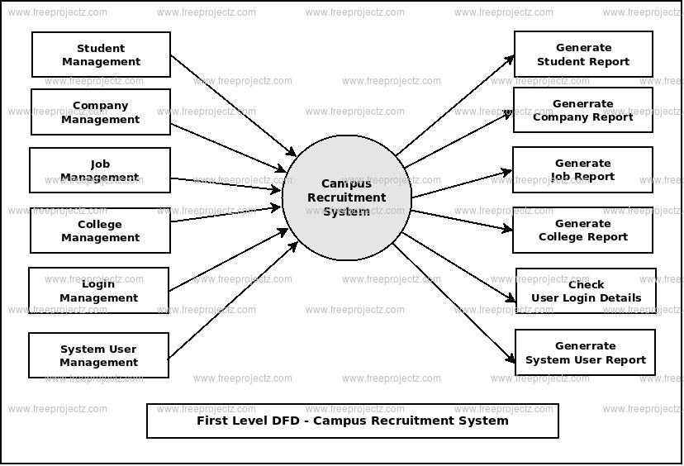

DATA FLOW DIAGRAM

**FUNCTIONAL STUDY**

**FUNCTIONAL REQUIREMENT**

R1:Registration

* **Description:**
* **To enter into this site user has to register himself first. Requirement of registration are first name last name and user name and email id and password and confirm password etc**
* **Input:user details**
* **Output:filled registration details**
* **Processing:user details are checked with database.password constraint is checked as pervalidation**
* **R2:USER LOGIN**
* **Description:the system provides facility to login into the system**
* **Input:enter user name and password**
* **Output:user profile page**
* **Processing: the system will check the input of user and if valid then login is done otherwise user will be asked to re enter the username password**

**R2:HR LOGIN**

**.>Description:the system provides hr to login into the system**

**.>Input:enter user name and password**

**.>Output:user profile page**

**.>Processing: the system will check the input of user and if valid then login is done otherwise user will be asked to re enter the username password**

THANK YOU